Scalable Machine Learning Algorithms for Big Data in Healthcare for Predictive Diagnosis Using PySpark and Apache Spark MLlib
The healthcare sector generates an enormous amount of data daily, ranging from patient records, medical imaging, sensor data, clinical trials, genomic data, to administrative records. The healthcare sector is confronted with an overwhelming volume, variety, and velocity of data, including patient records, medical imaging, and genomic data. This influx of information requires advanced digital technologies to effectively manage and analyse data to improve patient outcomes. Predictive models, particularly in diabetes care, offer a transformative approach by enabling early diagnosis and proactive intervention. Machine learning algorithms, applied to both historical and real-time data, can identify high-risk individuals before the onset of symptoms, allowing for personalised treatment plans that prevent complications and reduce healthcare costs. By shifting from reactive to proactive care, early detection can significantly improve patient outcomes and reduce the long-term burden of diabetes. (W Herman, 2015) “Major benefits are likely to accrue from the early diagnosis and treatment of glycemia and cardiovascular risk factors in type 2 diabetes”. Leveraging scalable technologies like Apache Spark, HDFS, PySpark MLlib, and AWS, this predictive healthcare solution can efficiently handle large datasets, making it adaptable for global implementation across healthcare organisations.

A notable precedent in this field is the study by Orlando Iparraguirre-Villanueva et al. (2023), titled Application of Machine Learning Models for Early Detection and Accurate Classification of Type 2 Diabetes. This study demonstrated the efficacy of several supervised machine learning algorithms—Random Forest (RF), K-Nearest Neighbours (KNN), Support Vector Machine (SVM), Naïve Bayes (NB), and Logistic Regression (LR)—for diabetes classification using clinical features. Their work validates the potential of ML-based screening tools in improving early diagnosis accuracy while highlighting model performance trade-offs in precision, recall, and computational complexity.
Building on this foundation, I have selected a dataset from the Centres for Disease Control and Prevention (CDC) that focuses on health indicators associated with diabetes. This dataset includes comprehensive patient records featuring demographic information, medical history, lifestyle factors, and clinical indicators linked to diabetes risk. Key attributes include age, gender, BMI, blood pressure, family medical history, and laboratory test results (D J. Magliano, 2021). According to estimates from 2021, approximately 537 million people worldwide are living with diabetes—a figure projected to rise to 643 million by 2030 and 783 million by 2045. Diabetes is now one of the most rapidly growing global health emergencies of the 21st century and ranks among the leading causes of death worldwide. These statistics underscore the critical need for early detection and the development of predictive models to identify individuals at risk.
To support this goal, the project will leverage the Hadoop Distributed File System (HDFS) for scalable data storage and Apache Spark for distributed data processing and machine learning. The dataset will undergo preprocessing to ensure quality and reliability. This includes handling missing values, normalising features, and selecting the most relevant variables for model training. Summary statistics, such as mean, standard deviation, and the range of values for each feature, will be computed to understand the distribution and potential biases in the data.
The primary hypothesis guiding this research is that early prediction of diabetes can significantly enhance healthcare outcomes. By identifying individuals at high risk before complications arise, medical professionals can initiate early interventions that improve long-term health. Predictive models can also help in tailoring treatment plans to individual risk profiles, reducing the likelihood of disease onset. Additionally, early diagnosis may lead to substantial reductions in healthcare costs by minimising the need for expensive treatments and hospitalisations. Another important consideration is that accurate predictions can help healthcare systems allocate resources more efficiently, prioritising care for those at the highest risk.
The main objective of this project is to build a scalable machine learning pipeline using PySpark and Apache Spark MLlib to predict the likelihood of diabetes. The process will begin with comprehensive data preprocessing, including data cleaning, categorical feature encoding, and normalisation. Feature selection techniques will be applied to identify the most influential predictors, and additional features may be engineered if necessary.
Multiple machine learning algorithms will be tested to determine the most effective model for diabetes prediction. These include Logistic Regression, Random Forest, and Gradient Boosting, all implemented using Spark MLlib. The models will be evaluated using performance metrics such as accuracy, precision, recall, F1-score, and AUC-ROC. A confusion matrix will also be generated to assess the model’s performance in distinguishing between true positives, false positives, true negatives, and false negatives.
The dataset, sourced from the UCI Repository, contains features highly relevant to diabetes risk prediction, including age, BMI, blood pressure, insulin levels, and family history. After initial preprocessing using imputation, normalisation, and standardisation techniques, the data will be transformed into a machine learning-ready format. This will include feature engineering, encoding categorical variables, and scaling numerical ones. In selecting predictive features for diabetes risk, this study aligns with the findings of Lugner et al. (2024), who used gradient boosting models on the UK Biobank dataset to identify the top ten predictors of type 2 diabetes, including HbA1c, fasting glucose, BMI, age, and waist-to-hip ratio. These features were found to provide the highest contribution to predictive accuracy across a large and diverse population.
Model training will use an 80/20 train-test split, supplemented by cross-validation to enhance generalizability. Feature selection methods such as feature importance ranking and recursive feature elimination will be used to improve performance and interpretability. Apache Spark will be used to build and manage the pipeline, taking advantage of its in-memory computing and data-parallelism capabilities for processing large-scale datasets. Once deployed, the model will be continuously monitored to assess its real-world performance. Feedback from healthcare providers and patient outcomes will guide iterative improvements. The model will be retrained periodically to incorporate newly collected data, maintaining its predictive accuracy over time.
The anticipated outcomes of this project include a robust and scalable machine learning pipeline for healthcare data, a high-performing predictive model for early diabetes detection, and broader system integration that enhances patient care. In addition to improving clinical outcomes, the project aims to reduce long-term healthcare costs and offer a framework that can be adapted to predict other chronic conditions.
Technologies utilized in the project include Hadoop Distributed File System (HDFS) for scalable data storage, Apache Spark MLlib for implementing Logistic Regression and Random Forest classifiers, Vector Assembler for feature engineering, and Binary Classification Evaluator for assessing model performance.

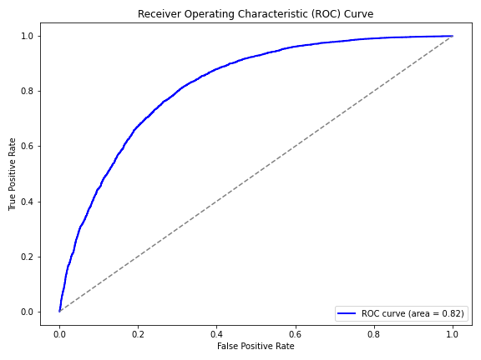
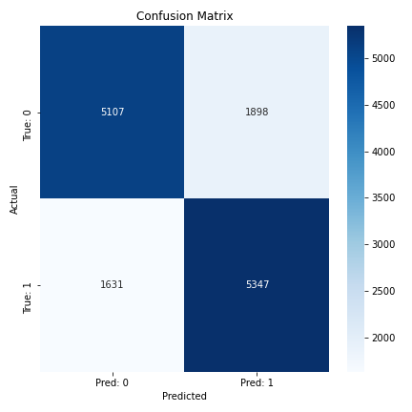
Results Summary
Logistic Regression:

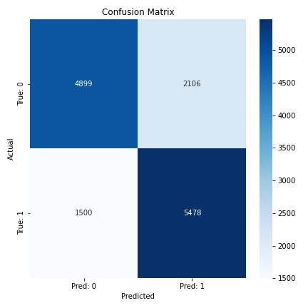
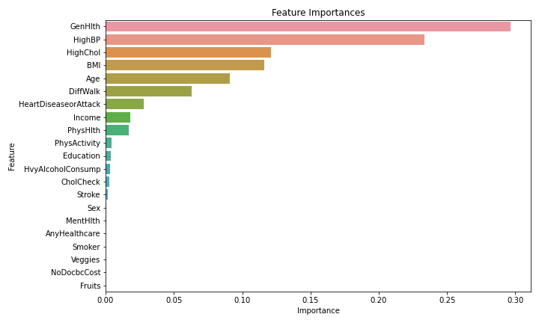
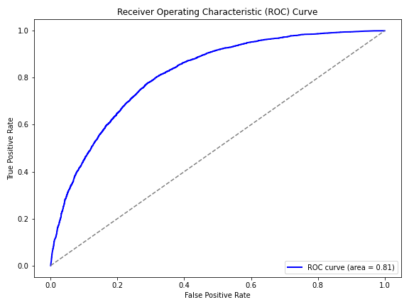
Random Forrest:

Gradient Boosting Classifier:

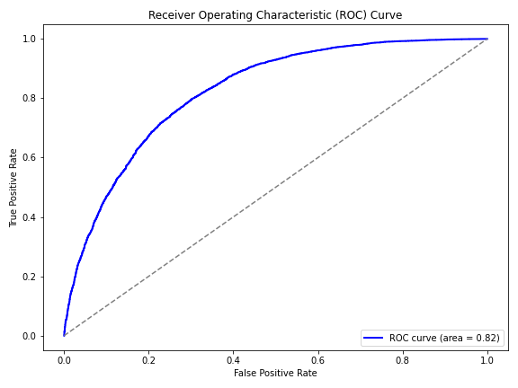
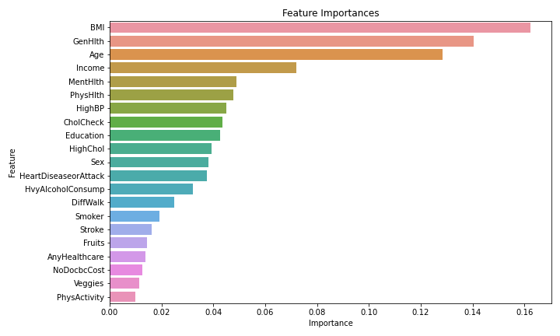
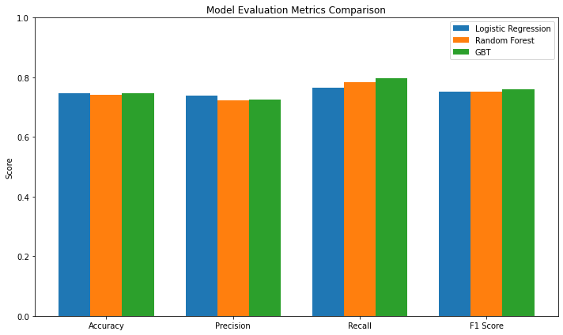
Model | AUC | Accuracy | Precision | Recall | F1-Score | ROC Curve AUC
Logistic Regression | 0.8219 | 0.7476 | 0.7380 | 0.7663 | 0.7519 | 0.8219
Random Forest | 0.8149 | 0.7421 | 0.7223 | 0.7850 | 0.7524 | 0.8149
Gradient Boosting | 0.8247 | 0.7475 | 0.7247 | 0.7966 | 0.7590 | 0.8247
Fig1: Model metric summary

Gradient Boosting Classifier demonstrated the best overall performance, achieving the highest AUC (0.8247) and F1-Score (0.7590), making it the most balanced and effective model for predicting diabetes risk. Logistic Regression had competitive metrics, particularly with high precision (0.7380) and accuracy (0.7476), and offers better interpretability, which is valuable in clinical settings. Random Forest showed slightly lower AUC and precision but achieved a strong recall (0.7850), which is crucial in medical applications where false negatives must be minimised. The consistently high AUC values (≥0.81) across all models indicate strong discriminative power. Recall scores above 0.76 suggest that all models are effective in identifying individuals at risk for diabetes, with Gradient Boosting performing best in this regard. While Gradient Boosting is computationally more expensive, its marginal performance gains justify its selection in contexts where predictive accuracy is a priority.
Based on this analysis, Gradient Boosting is the preferred model due to its superior recall and F1-score, particularly in healthcare applications where early and accurate identification of at-risk patients is critical. However, Logistic Regression remains a viable alternative in scenarios requiring model simplicity and explainability. Although the CDC Diabetes Health Indicators dataset is comprehensive, it may contain inherent biases due to underreporting, regional focus (mostly the U.S. population), or self-reported information, which can affect the generalizability of the model to other populations or geographies. Also, while ensemble models like Random Forest and Gradient Boosting offer high accuracy, they are less interpretable compared to simpler models. In medical contexts, a lack of transparency can be a barrier to adoption by healthcare professionals. Integrating the predictive model into existing healthcare infrastructure (e.g., Electronic Health Record systems) can be complex and may require significant customisation, technical support, and staff training.
Models trained on the CDC dataset might not generalise well to populations in other countries or healthcare systems without retraining or domain adaptation, which requires additional labelled data from those environments and handling healthcare data, even in anonymised form, raises privacy and ethical concerns. Strict compliance with data protection regulations (e.g., HIPAA or GDPR) is required when deploying the system in real-world healthcare environments.

References
Diabetes Health Indicators Dataset https://www.kaggle.com/datasets/alexteboul/diabetes-health-indicators-dataset
Orlando Iparraguirre-Villanueva, Karina Espinola-Linares, Rosalynn Ornella Flores Castañeda, Michael Cabanillas-Carbonell, (2023), Application of Machine Learning Models for Early Detection and Accurate Classification of Type 2 Diabetes , 4, PMID: 37510127 doi: 10.3390/diagnostics13142383
Magliano DJ , Boyko EJ , (2021) IDF Diabetes Atlas 10th edition scientific committee10th edition, Review from International Diabetes Federation, Brussels, PMID: 35914061
William H. Herman; Wen Ye; Simon J. Griffin; Rebecca K. Simmons; Melanie J. Davies; Kamlesh Khunti; Guy E.H.M. Rutten; Annelli Sandbaek; Torsten Lauritzen; Knut Borch-Johnsen; Morton B. Brown; Nicholas J. Wareham, (2015) Epidemiology / Health Services Research, Early Detection and Treatment of Type 2 Diabetes Reduce Cardiovascular Morbidity and Mortality: A Simulation of the Results of the Anglo-Danish-Dutch Study of Intensive Treatment in People With Screen-Detected Diabetes in Primary Care (ADDITION-Europe), Diabetes Care 2015;38(8):1449–1455 https://doi.org/10.2337/dc14-2459
Lugner, M., Rawshani, A., Helleryd, E. et al. Identifying top ten predictors of type 2 diabetes through machine learning analysis of UK Biobank data. Sci Rep 14, 2102 (2024). https://doi.org/10.1038/s41598-024-52023-5

